Call for Academic Presentations & Posters

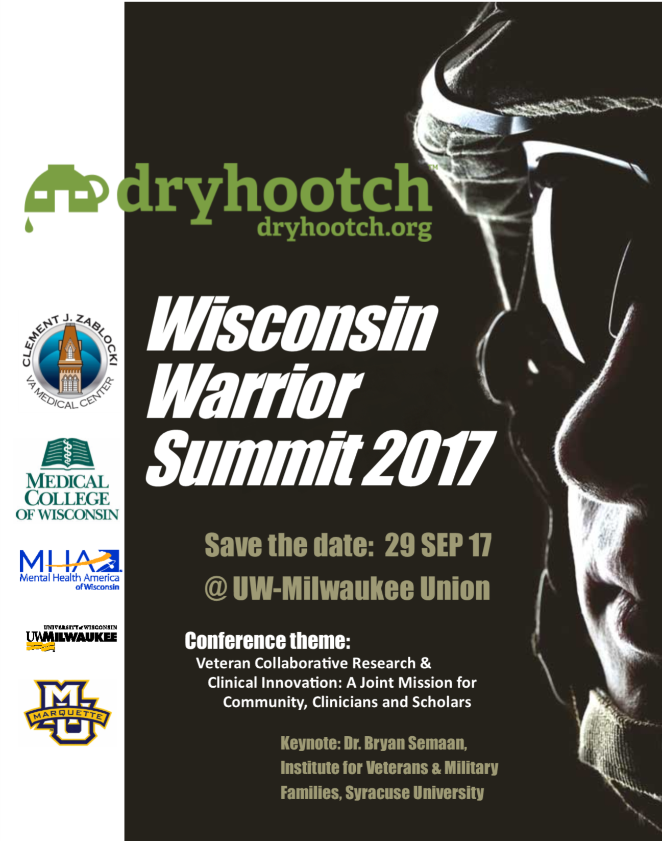

Wisconsin Warrior Summit 2017
Call for Academic Presentations & Posters
Date: Friday, September 29th, 2017
Location: University of Wisconsin, Milwaukee – Union Building
Keynote Speaker: Dr. Bryan Semaan, Institute for Veterans and Military Families, Syracuse University.
Website: http://dryhootchpartners4health.org/warrior-summit/

SUBMISSION DEADLINE: August 18, 2017

The Dryhootch Partnership for Veteran Health, a community/academic partnership, is seeking abstract submissions for posters and oral breakout session presentations that describe scholarly projects, research and/or lesson learned from projects working with veterans, active duty, and military families as part of the Wisconsin Warrior Summit. Submissions will undergo peer review and will be published as a local conference proceedings document. Accepted teams will also be encouraged to join a special issue effort on veteran community engaged research.

Conference Theme: Veteran Collaborative Research & Clinical Innovation:
A Joint Mission for Community, Clinicians and Scholars
SUGGESTED THEMES FOR SUBMISSIONS:
- Post Deployment Experiences
- Civilian Reintegration
- Moral Injury
- Information systems and mobile health
- Veteran Courts
- Post Traumatic Stress Disorder
- Depression and suicide prevention
- Military families
- Treatment advances
- Wrap-around services
- Veteran peer mentorship
- Employment & retraining
- Veteran studies
- Military experience and the arts
- Community partnership strategies with veteran organizations

PRESENTATION TYPES: The academic portion of the conference will include two types of presentations
- Collaborative, interdisciplinary symposia: 90-minute group presentations optimally integrating veteran, researcher/scholar, and clinical perspectives on collaboratively developed projects designed to address complex issues with veteran care. Projects can be at any stage of development, but should be able to demonstrate meaningful engagement across the perspectives of the different stakeholder groups, negotiating differences in approach and priorities. Projects that utilize a Community-Based Participatory Research (CBPR), Community Engagement in Research (CEnR), or Collaborative Design perspective are particularly encouraged to apply.
- Extended Poster Discussion: Posters focused on research, scholarship, and/or clinical innovation focused on veterans. Poster session is designed to encourage active discussion between presenters and attendees from a wide variety of backgrounds. Veteran related projects at any stage are welcome, including undergraduate and graduate student research, as well as works by veterans and veteran serving organizations.

Submission Format: Please complete attached submission form with an abstract (maximum 250 words). We welcome abstracts of original work that have not been peer reviewed previously and those that have been peer reviewed and accepted for presentation at another meeting – but have not yet been presented regionally in the Midwest. Projects involving human subjects research are expected to comply with IRB/regulatory considerations. Complete required information on the abstract form.
NOTE: Posters and presentations will be judged in part on their ability to communicate findings to a broad audience that includes non-academics.

____________________________________________________________________________

2017 Wisconsin Warrior Summit
Abstract Submission Form

A. Answer the following about your proposal:
☐ BREAKOUT SESSION (90 MINUTES) ☐ POSTER ☐ EITHER
B. Title of Abstract:
C. Author/s (Full Names, Affiliations and Email Addresses)
First Author:
Role: ☐ Veteran ☐ Researcher/Scholar ☐ Clinician ☐ Other___________
Second Author:
Role: ☐ Veteran ☐ Researcher/Scholar ☐ Clinician ☐ Other___________
Third Author:
Role: ☐ Veteran ☐ Researcher/Scholar ☐ Clinician ☐ Other___________
Additional Contributors:

D. Abstract – Complete for both symposia and poster presentation formats (Limit to 250 words):

E. Partnership Description. Symposia presentations must also complete a brief statement outlining the history of the partnership, learnings each stakeholder group has taken from the process of collaboration, and how the partnership has evolved over time. (Limit 100 words):

Deadline for Abstracts: August 18, 2017
E-mail this completed form to wi.warriorsummit@gmail.com
Phone support: (414) 955-4372
Registration information:
http://dryhootchpartners4health.org/warrior-summit/

Conference Program Committee:
Zeno Franco, PhD, Medical College of Wisconsin
Leslie Ruffalo, PhD, Medical College of Wisconsin
Katinka Hooyer, PhD, Medical College of Wisconsin
Mark Flower, Dryhootch of America
Ginny Stoffel, PhD, University of Wisconsin, Milwaukee
Karen Berte, PhD, Medical College of Wisconsin
Jeff Whittle, MD, MPH, Milwaukee (Zablocki) VA Medical Center
Jayne Holland, M.Ed., University of Wisconsin, Milwaukee
Martina Graves, President, Mental Health America of Wisconsin
Sheikh Iqbal Ahamed, PhD, Marquette University
Bob Curry, President, Dryhootch of America

